This is a logbook entry to complete and email to your faculty supervisor as progress update on a biweekly basis (i.e. once every 2 weeks). Your submissions will be used as reference for your internship progress and will be assessed towards the overall performance of your internship journal.

Important Note:
- As consistency of submissions is assessed as part of your internship, all submissions should be made on time. Any delays should be informed and prior approval to be sought with your faculty supervisor. Late entries without prior approval will be considered invalid for assessment.
- Before submission, please obtain clearance for your logbook content from your organisation supervisor to ensure that no confidential information is included.

Student Name | : | Tan Yi Rong
Student ID | : | U2320967K
Company Name | : | GlobalFoundries
Company Supervisor | : | Ng, Christopher
Logbook Entry Period | : | 22/06/2026 to 03/07/2026
Date of Submission | : | 07/07/2026

- State the Internship Objective, Scope, and Problem Statement
(Briefly describe the objective(s) provided by the internship organisation, and the expected scope of work and deliverables expected from you to address the issues.)
Objective:
The objective of this internship is to support the Automated Material Handling System (AMHS) department in improving Overhead Hoist Transport (OHT) maintenance data collection and predictive maintenance requirements for parts replacement. This is intended to reduce error occurrences and improve operational performance during production.

Scope of Work:
- Understudy AMHS operation and OHT Preventive Maintenance (PM) process during the initial stage of the internship.
- Continuation of Project Odin, which focuses on OHT wheel measurement through sensor testing and data collection for Predictive Maintenance.
- Carry out preliminary industry-attached FYP scoping and research related to AMHS and OHT maintenance improvement.
- Attend team meetings, daily progress reviews and support documentation and other ad-hoc AMHS-related tasks where required.

Problem Statement:
The current OHT maintenance and condition monitoring process requires more effective and reliable methods of data collection, analysis and maintenance planning. Without sufficient monitoring and process improvement, maintenance activities may remain reactive, labour-intensive and more prone to inconsistency. This internship focuses on understanding current workflow, supporting ongoing wheel monitoring and Predictive Maintenance (PdM) efforts and exploring ideas that may improve maintenance efficiency, safety and ease of line support work.

- Describe your work done over the past 2 weeks
Work and/or Tasks Performed | Date (From) | Date (To)
Sketchup on OHT Maintenance Bay | 22/06/26 | continuation
Manufacturing Team Bonding Organization, planning and coordination | 24/06/26 | 25/06/26
OMRON Site Visit for Robot Arm experience and Vendor engagement | 26/06/26 | 26/06/26
Vendor alternative sourcing and feasibility studies | 27/06/26 | continuation
Software development (in progress) | 22/06/26 | continuation
Sensor Reading Data Sorting and Preparation | 29/06/26 | 30/06/26
AI Model Image Training and Testing | 31/06/26 | continuation

Describe and reflect on your work/task outcome/learning over the last 2 weeks

(Illustrate the challenges that you are facing; describe areas that you have done well and areas that could be better managed)

WORK DONE
During this period, work focused on improving the OHT Mark 2 PM Workflow Simulator and engaging with the wider manufacturing team. On June 24th and 25th (after work hours), I helped out the organizing team for the Manufacturing Team Bonding session held at Fab 7H. I helped facilitate the smooth flow of the event, managed the photobooth and captured memorable moments as colleagues played games and bonded, fostering a cohesive team environment.
On June 26th, I conducted an off-site visit to the OMRON facility with my colleague. The purpose of this visit was to physically evaluate their collaborative robot arm capabilities and explore other potential automation products that could be used for our PM process. Following this, I began actively sourcing for alternative vendors and conducting feasibility studies on DIY solutions.
On the software side, the first step involved reorganizing the existing simulator files. By splitting the code into cleaner, separate folders, the application became much easier to manage and update. Next, a large batch of over 400 sensor reading images was reviewed and sorted. The images were carefully categorized into "Obstacle Detected" and "Clear" folders. These organized images were then used to train an Artificial Intelligence (AI) model, teaching it how to correctly identify whether an obstacle is present or not.
This is currently still in the testing phase, I’m still trying to tweak the sensor’s boundary conditions.
KNOWLEDGE AND SKILLS GAINED
Being part of the organizing team for the Fab 7H bonding event provided valuable experience in event facilitation, team coordination and actively contributing to a positive workplace culture. The site visit to OMRON also provided practical, hands-on exposure to industrial robotics and automation hardware. I gained valuable experience in evaluating a vendor's technical capabilities, comparing market prices and formulating backup engineering plans when budget constraints are met.
Through the image sorting and AI training phases, a practical understanding of how machine learning works was gained. This included learning how important it is to have clean, properly labelled data to teach a system effectively. The integration phase provided valuable insight into how smart features are added to existing software. Knowledge was gained in bridging different technologies together, such as taking a trained AI model and making it work smoothly inside a standard Windows application.
CHALLENGES FACED
A major project management challenge encountered was discovering that the OMRON vendor quotation greatly exceeded our project budget. Consequently, I am currently scouting for alternative vendors and comparing prices. One alternative solution being explored is to DIY a robot arm. However, this approach would lack vision capabilities, making the automated plug connection difficult to align. To solve this, the current 4-port plug would need to be replaced with a centralized single magnetic plug to ensure proper alignment by feel rather than vision. If this magnetic plug solution is adopted, all OHTs in the fab would eventually require this future implementation. This introduces a complex new engineering challenge: I would need to completely redesign the electrical circuit to ensure proper connectivity for the integration, which will likely require adding a relay system to switch seamlessly between the different sensors.
On the software side, a main challenge during this period was figuring out how to use the AI model to help with image learning and training. Currently couldn’t test with the live sensors which is a huge constraint as I would need to procure or dismantle the sensors from the OHT to be able to do the live testing. Another problem encountered, the sensor would be scanning in a 180-degree direction at a 100 frames per second which would cause the image capturing verification to be inaccurate and tough for the AI to determine whether it is good.

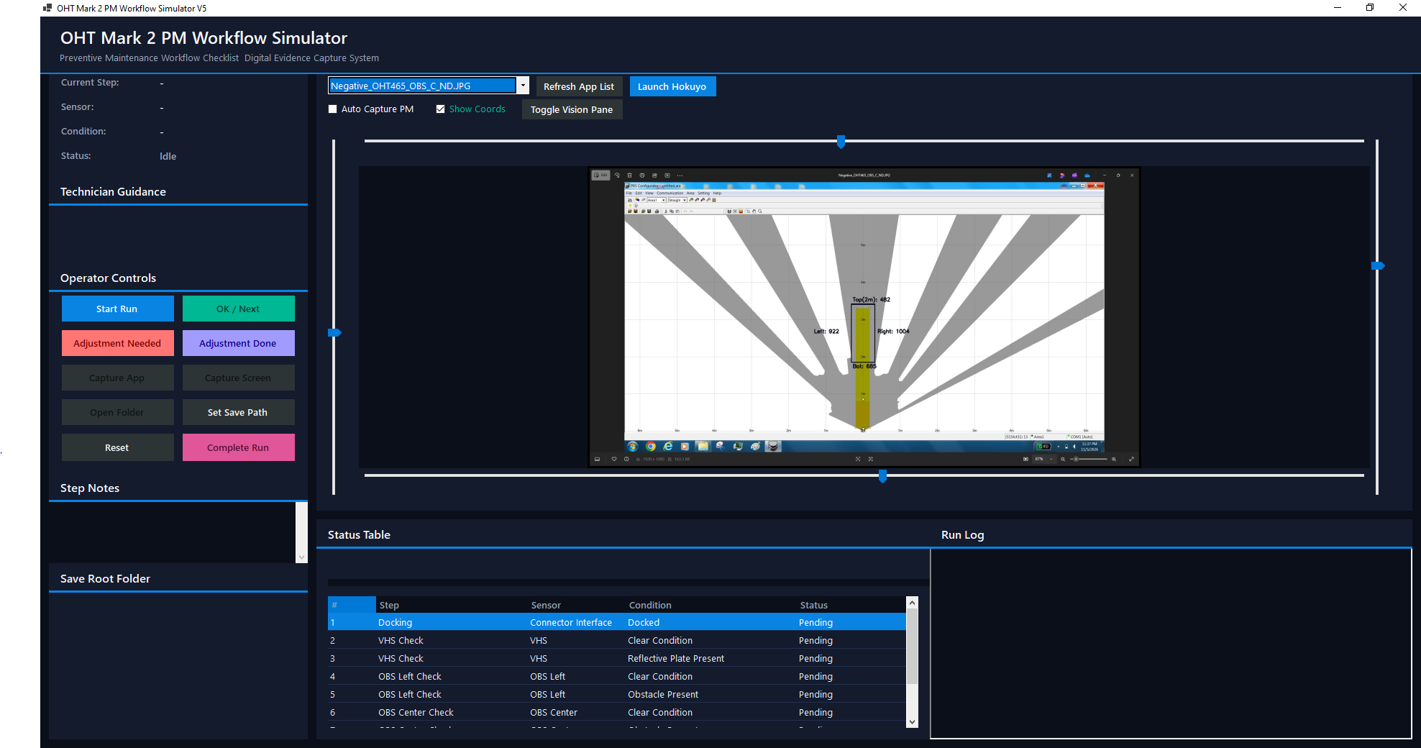
User Interface for Preventive Maintenance Workflow Simulator (Updated Version)
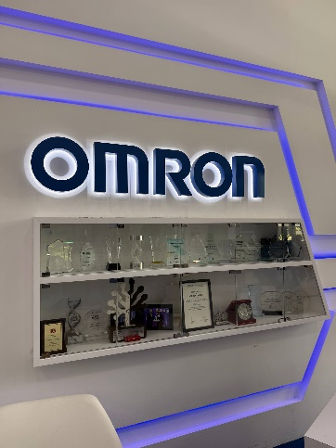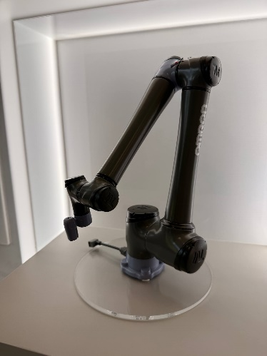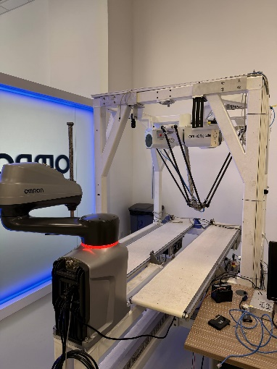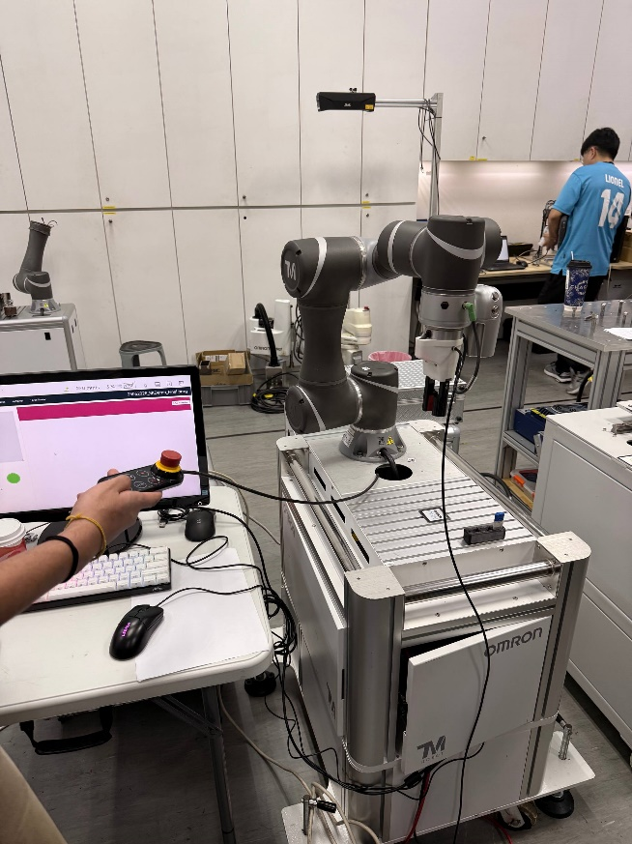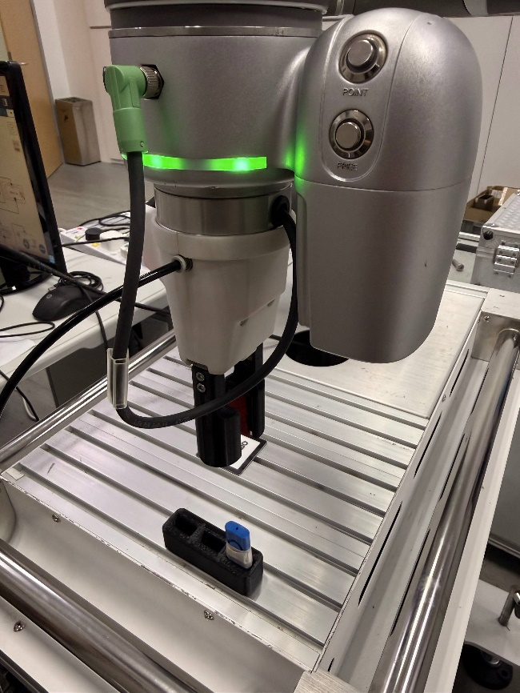
OMRON Site Visit

